A Very Bad Financial Decision

Dr. Bernard Dolansky

Mr. Bill Henderson

Selling a successful dental practice is a very bad financial decision.

It may seem strange, or at the very least, counter-intuitive, that people who deal in the sale of dental practices would categorize the decision to sell a practice as a bad financial decision.

However, anyone who has been paying attention to the evolving ownership patterns for dental practices in Ontario is aware of the increasing number of practices that are being sold to large corporate groups that are buying and own multiple practices. The primary drivers of this very visible phenomenon are the availability of a pool of dentists willing to work as non-owners (associates); the increasing amount of investment capital that is coming into the dental practice market; and the great returns on investment that dental practice ownership provides. These are all topics that we have discussed in previous OD articles.

As can be seen in Figure 1, the present Ontario market for general dental practices is very strong with much of the increase occurring in the last several years. But even at these higher values most established dental practices offer their owner a return on investment (after paying themselves market rates for their own work) ranging from 15-20% before tax with a low level of financial risk. Conversely, any money received by an owner from the sale of a dental practice and placed in a low risk investment is going to return 2-6% before tax, depending on the investment. Obviously, this would be a questionable decision if viewed strictly from the financial perspective.

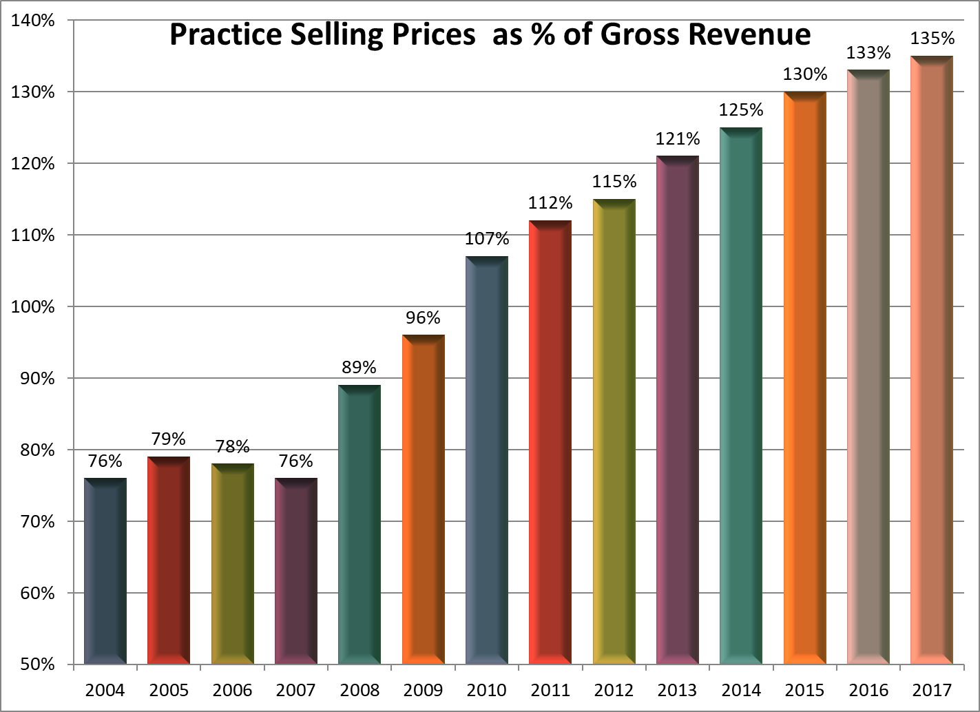

Figure 1. Average Selling Prices for General Practices in Ontario

So why would anyone ever sell a dental practice?

“I love doing dentistry but I’m tired of running a practice” is an opinion that we often hear from our dentist clients and this observation is often the driving factor in the decision to sell a practice. This makes the decision to sell a quite valid life-style decision, while remaining a poor financial decision.

Another market factor that can’t be overlooked in the decision to sell a general dental practice are the aggressive tactics of practice buyers in the present very strong sellers’ market. At a recent ODA CE presentation entitled “What You Need To Know Before You Buy Or Sell A Dental Practice” the sellers in the audience were polled on the question “How many of you have had an unsolicited approach to sell your practice?” One hundred percent of the sellers responded in the affirmative!

This is affirmation that so-called “cold calling” of dentists whose practices meet certain criteria is occurring in Ontario. These criteria include production >$1.5 million and an owner willing to stay on for at least 5 more years. And the solution that is being offered is tailored to be an answer to the bad-financial-decision but good life-style conundrum.

Because the best financial (and life-style) decisions should be made based on the best possible knowledge of the facts the seller should be as aware as possible of the financial implications of their decision.

These include knowing:
- what would the practice be worth on the open market versus what is being offered by the single buyer?
-will there be a holdback of a portion of the selling price?
-what are the strings attached to that holdback in terms of production “goals”?
-are you getting the fairest compensation possible while you will be practicing as an associate?
-will the seller be required to retain partial ownership of the practice or ownership in the larger corporate entity?
-how liquid will those retained ownership positions be when you’re ready to divest them?

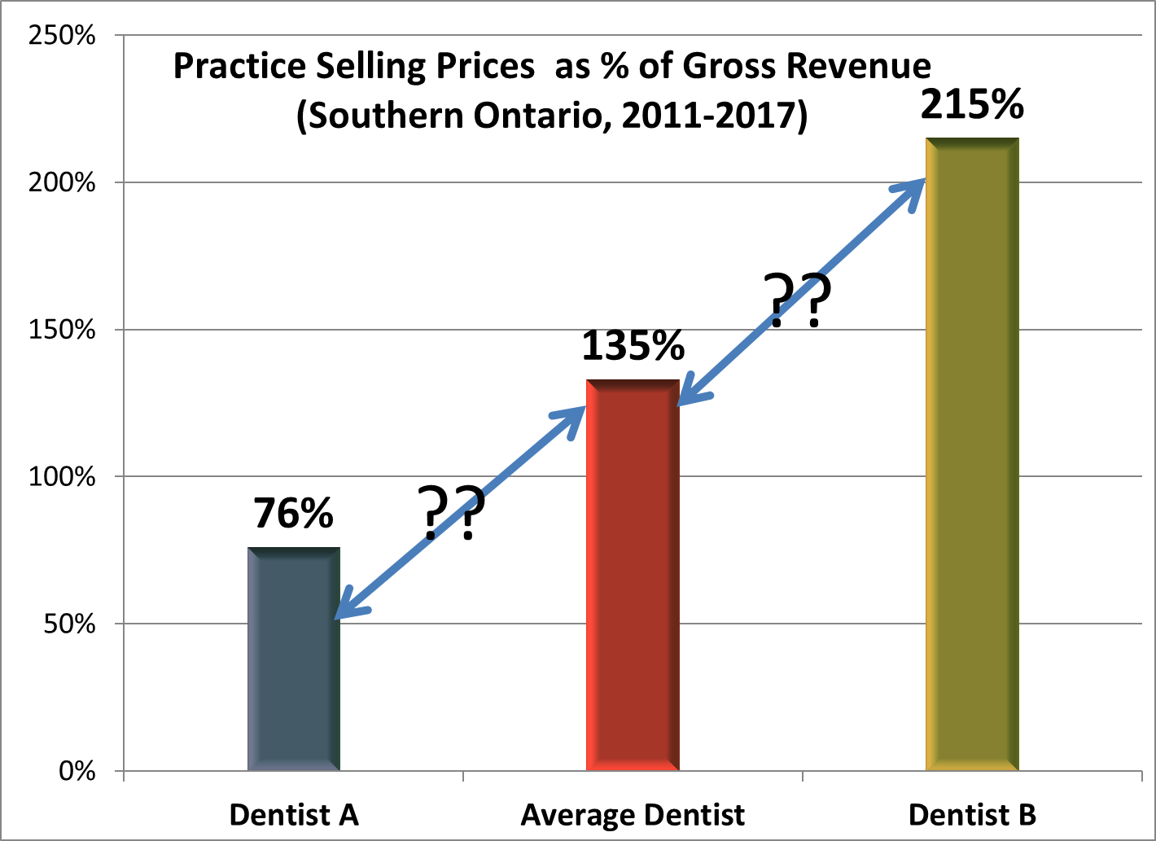
Figure 2 Range of Average Selling Prices Of Southern Ontario General Practices

Weighing the factors that drive your life-style and your financial decisions will be different for each individual and can represent difficult choices. With Ontario general dental practices selling in a range of 76-215% of revenue (Figure 2) you need to be as well informed as possible about the true value of your own practice. And at the very least anyone contemplating the sale of a dental practice also needs to be informed about the probable financial consequences of their decision including obtaining answers to the previous questions. Personal finances and life-style go hand in hand so there is a strong consequential link between financial realities and life-style.

One of the advantages of a strong sellers’ market is that it tends to give the seller a range of options and that is certainly true of the present strong Ontario market for general dental practices. Some of those options will be a better fit than others depending on each dentist’s needs and wants so the key to making the best choice is to become as knowledgeable as possible about all of the options that are presently available in the market for dental practice sales.

